Jan KOWALSKI¹, Stanisław NOWAK²
West Pomeranian University of Technology, Szczecin, Department of Electric Machines (1)
University of Zielona Góra, Instytut Inżynierii Elektrycznej (2)

Electric machine with permanent magnets

Abstract. Lorem ipsum Lorem ipsum Lorem ipsum Lorem ipsum Lorem ipsum Lorem ipsum Lorem ipsum Lorem ipsum Lorem ipsum Lorem ipsum Lorem ipsum Lorem ipsum Lorem ipsum Lorem ipsum Lorem ipsum Lorem ipsum Lorem ipsum Lorem ipsum Lorem ipsum Lorem ipsum Lorem ipsum Lorem ipsum Lorem ipsum Lorem ipsum.

Keywords: lorem ipsum, lorem ipsum, lorem ipsum, lorem ipsum, lorem ipsum.

Design of the machine
Lorem ipsum, lorem ipsum, lorem ipsum, lorem ipsum, lorem ipsum, lorem ipsum, lorem ipsum, lorem ipsum, lorem ipsum, lorem ipsum, lorem ipsum, lorem ipsum, lorem ipsum, lorem ipsum, lorem ipsum, lorem ipsum, lorem ipsum, lorem ipsum, Fig. 1. Lorem ipsum, lorem ipsum, lorem ipsum, lorem ipsum, lorem ipsum, lorem ipsum, lorem ipsum, lorem ipsum, lorem ipsum, lorem ipsum, lorem ipsum, lorem ipsum, lorem ipsum.
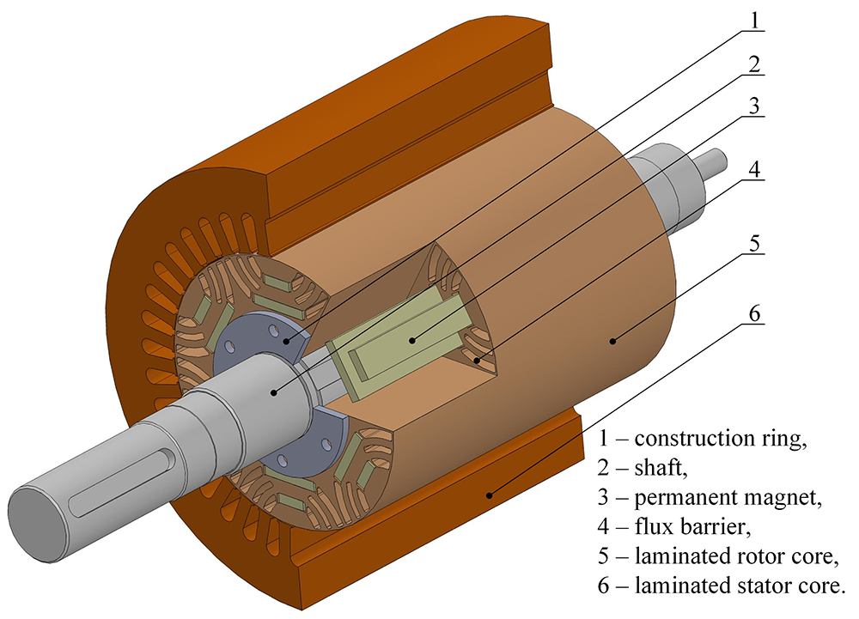

Fig.1. Suggested structure of the machine.

Experimental validation
Lorem ipsum, lorem ipsum, lorem ipsum, lorem ipsum, lorem ipsum, lorem ipsum, lorem ipsum, lorem ipsum, lorem ipsum, lorem ipsum, lorem ipsum, lorem ipsum, lorem ipsum, lorem ipsum, lorem ipsum, lorem ipsum, lorem ipsum, lorem ipsum, lorem ipsum, lorem ipsum, lorem ipsum, Fig. 2.

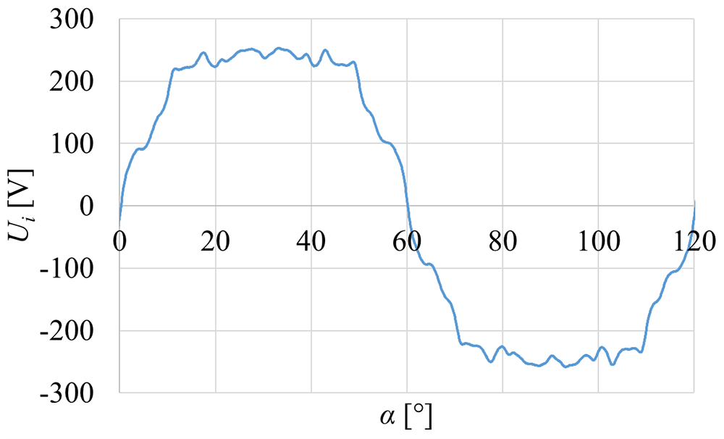
Fig.2. Test results of the machine.

Conclusion
Lorem ipsum, lorem ipsum, lorem ipsum, lorem ipsum, lorem ipsum, lorem ipsum, lorem ipsum, lorem ipsum, lorem ipsum, lorem ipsum, lorem ipsum, lorem ipsum, lorem ipsum, lorem ipsum, lorem ipsum, lorem ipsum, lorem ipsum, lorem ipsum, lorem ipsum, lorem ipsum, lorem ipsum.

References
- Youguang Guo, Student Member, IEEE, Jian Guo Zhu, Senior Member, IEEE, Jin Jiang Zhong, and Wei Wu, Core Losses in Claw Pole Permanent Magnet Machines With Soft Magnetic Composite Stators, IEEE Transactions on Magnetics, vol. 39, no. 5, 2003, pp. 3199-3201.
- Y. Burkhardt, K. Schleicher, M. Klöpzig, A novel hybrid excited synchronous machine for (H)EV applications, IEEE Xplore, 2014.

Authors: prof. dr hab. inż. Jan Kowalski, West Pomeranian University of Technology, Szczecin, Sikorskiego 37, 70-313 Szczecin, e-mail: jan.kowalski@zut.edu.pl; prof. dr hab. inż. Stanisław Nowak, Uniwersity of Zielona Góra, Instytut Inżynierii Elektrycznej, Podgórna 50, 65-246 Zielona Góra, e-mail: stanislaw.nowak@uz.zgora.pl.

